How to use the Columbia County Neighbor Lookup App

Navigate to the App:

https://cc-ny.maps.arcgis.com/apps/instant/notification/index.html?appid=37067a55d88a4a3498b2931354bc4ce5

In the map, zoom in to the parcel in question and click the “Create new list” button:
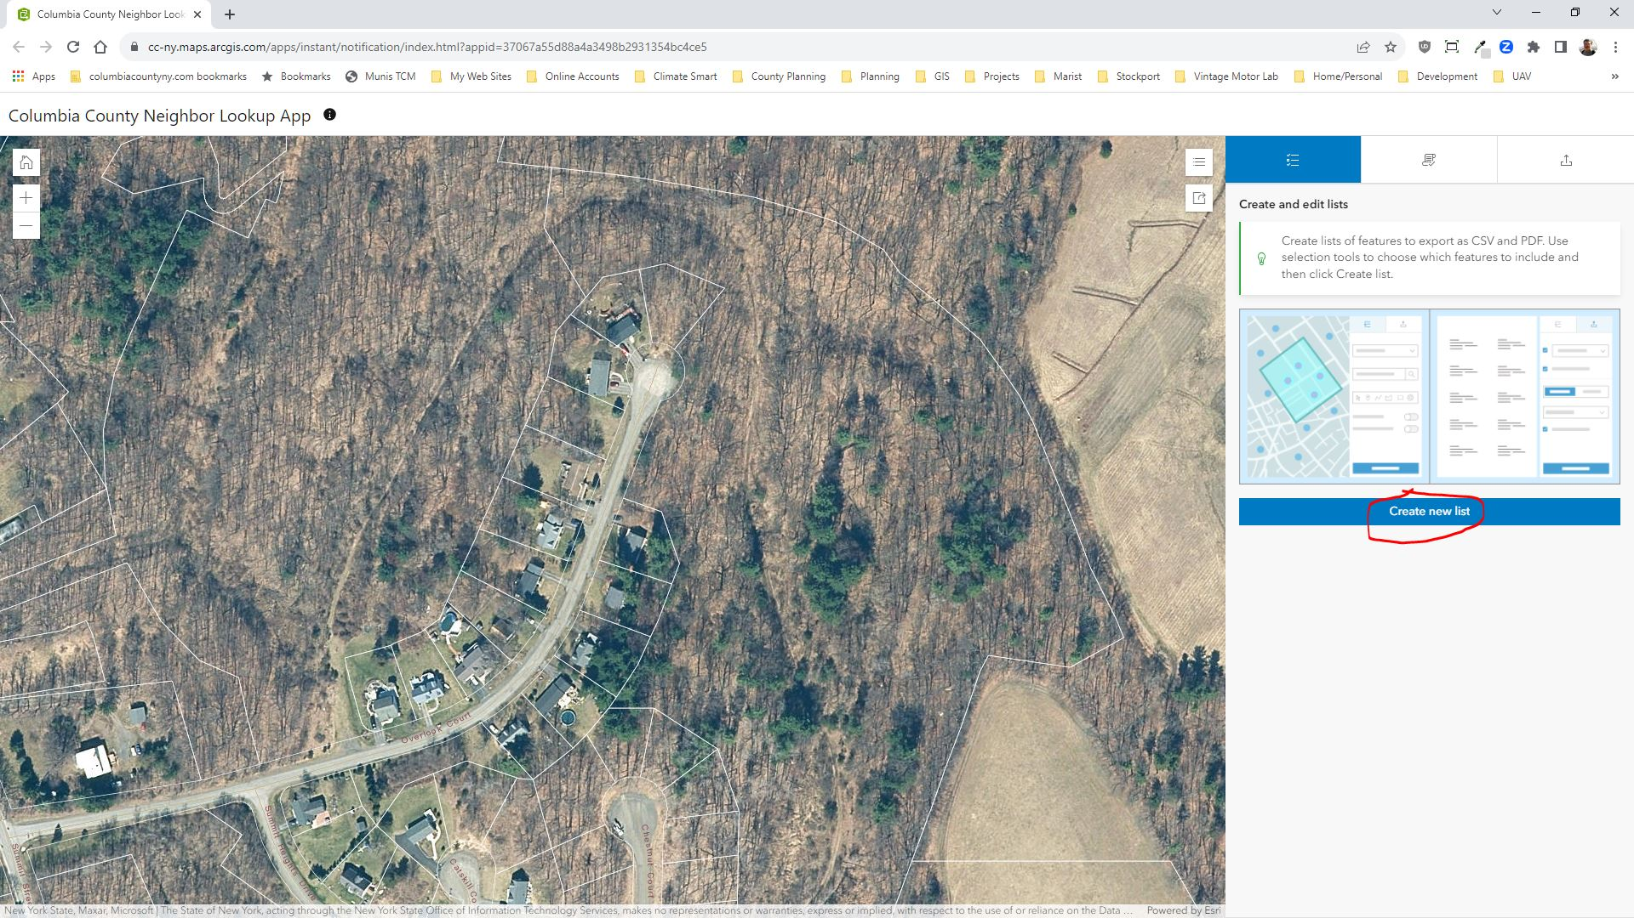

In the next panel, turn on the “Search distance” option and enter a search distance. 500 Feet is the default. You can change it if you like. If your search is for a distance from the boundary of a tax parcel, turn on the “Use layer features” option. If you do not turn on this option the list of selected parcels will be a distance from the point, line, or polygon that you will draw in the next step, not the parcel boundary.
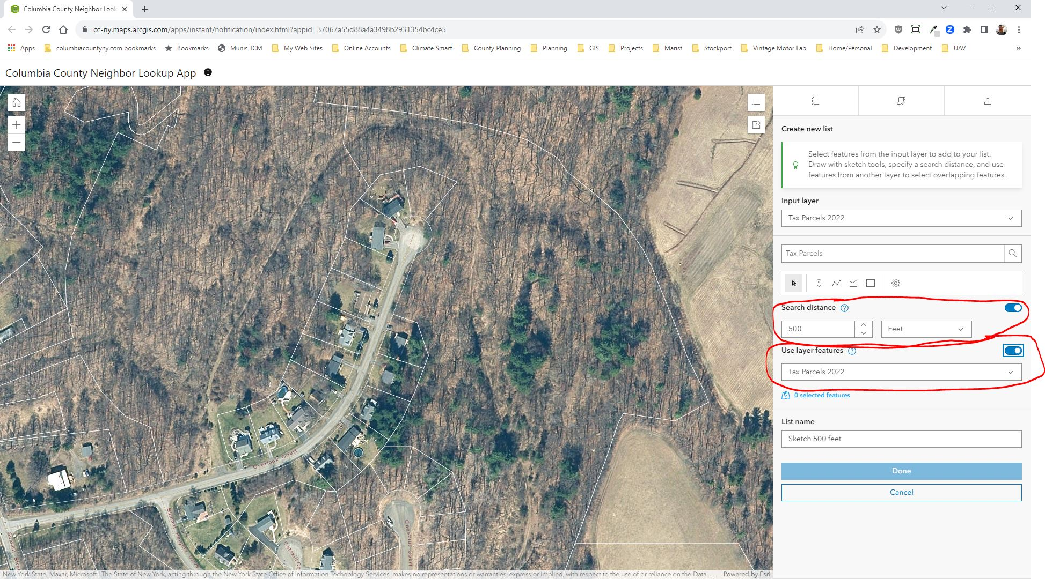

To select a single parcel to search from, hover over and click on the “Draw a point” tool.

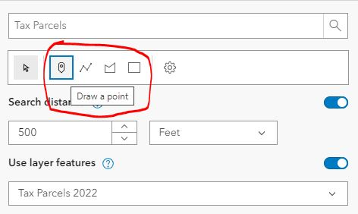

If you want to select multiple tax parcels you can use the “Draw a polyline, polygon, or rectangle tools, and make a drawing inside all of the tax parcels you want to use for your search. With the polyline and polygon tools you have to double-click to place your last vertex and end the drawing. With the rectangle tool you have to click, hold, and drag the cursor to make the rectangle.

Once the drawing is made, a buffer is shown around the selected parcel(s) at the given search distance, and all the parcels that are completely or partially within that buffer are selected. You can give your selection a name in the “List name” box, and click on the “Done” button to save it.
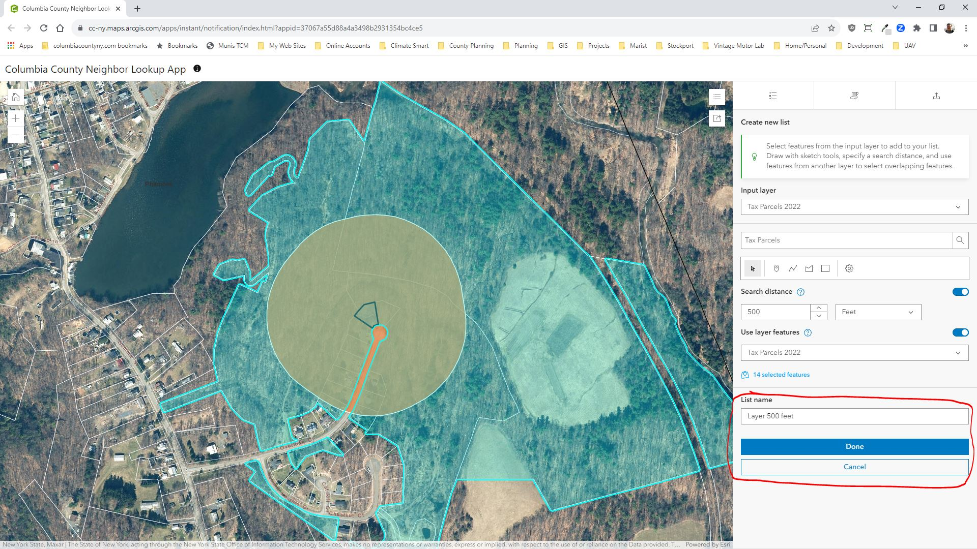

Optionally, you can use the “Refine selection” panel to add or remove specific parcels from the selection. Choose Add or Remove, and use the selection tools to add or remove parcels from the selection list.
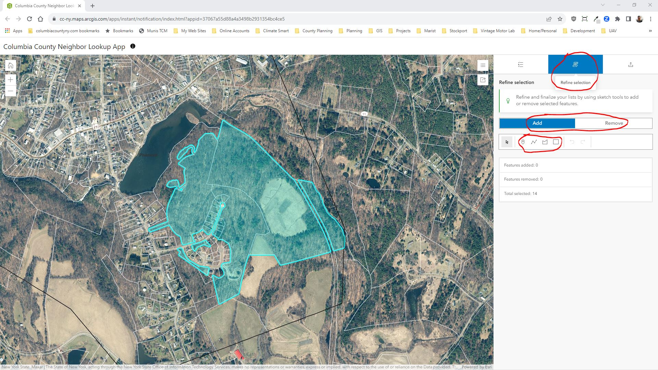

When your selection list is complete, use the “Export” panel to save your list.
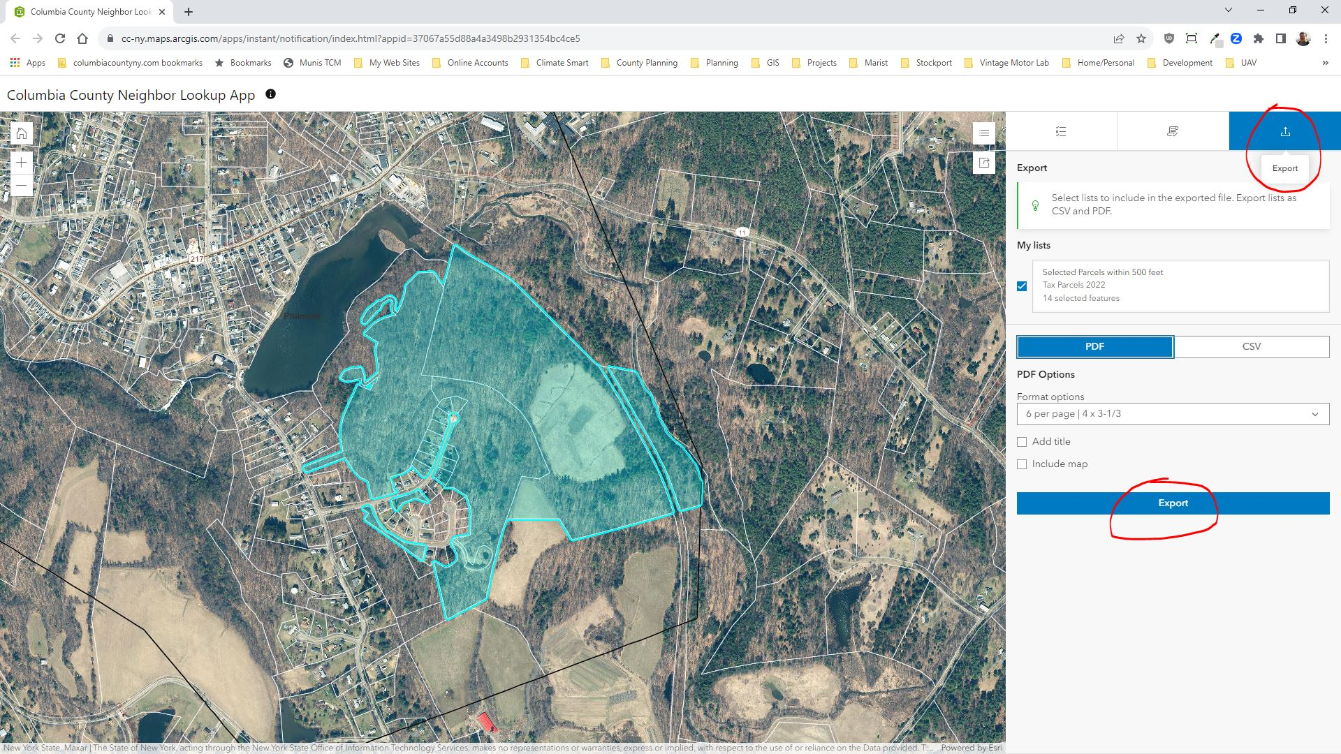

You can save your list as a PDF with a variety of label size and layout options. Or you can save it as a “CSV” spreadsheet which you can open in Excel.

Any questions, please contact Don Meltz: donald.meltz@columbiacountyny.com

